**VS Code Link** - <https://code.visualstudio.com/download>

**Git Bash Link** - <https://git-scm.com/downloads>

**Zoom Link:** <https://zoom.us/download>

**MingW Compiler** - <https://drive.google.com/file/d/1DNi19ocKwHWopyYCfTHZGM96puRsGtOQ/view?fbclid=IwAR2ZPt_uPr-w2tmD9CN8I1JiQ3wVs-uwv3Rz9LoA0rljd7Tp0PyM3GjqTwY>

**Settings.json** - <https://docs.google.com/document/d/1cxFvTnr9TbuhRU7hthAVlhA928wybyYEQJOaBFKd_sc/edit?usp=sharing>

//code-1 => Paste it and run the code; you will see the result.

#include<stdio.h>

int main(){

printf("Hello world!");

return 0;

}

//code-2 => Paste it and run the code; take input, and then you will see the result

#include<stdio.h>

int main(){

int a;

scanf("%d",&a);

printf("a = %d",a);

return 0;

}

Shortcut Key:

| **Operation** | **Command** |
| --- | --- |
| Copy | Ctrl + C |
| Paste | Ctrl + V |
| All select | Ctrl + A |
| Command Prompt | + R,then type cmd → Press Enter |

Extension 1:

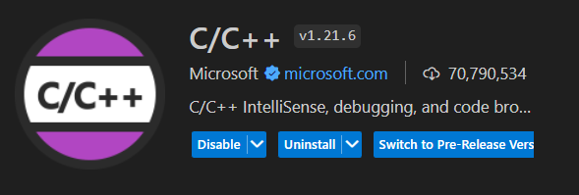

Extension 2:

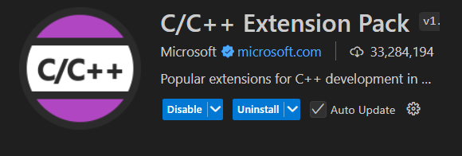

Extension 3:

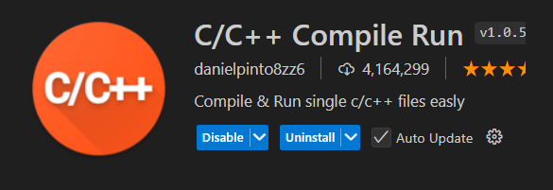

Extension 4:

